Order Management Platform

NAME : Theertha N S
Batch 2 Data Engineer

PROJECT OVERVIEW

This project demonstrates the implementation of a DevOps workflow for a Retail E-Commerce Order Management Platform using Python Flask, GitHub, GitHub Actions, and Trello.

The project includes Agile planning, source control management, CI automation, automated testing, and build verification. The application exposes APIs for service health check, order status, and inventory status.

The complete workflow was managed using Trello for Agile planning and GitHub Actions for Continuous Integration.

PROJECT OBJECTIVE

The objective of this project is to build and automate a CI workflow for a Retail Order Management Platform. The project focuses on Agile task planning, application development, automated testing, repository management, and CI pipeline automation using GitHub Actions.

TECHNOLOGIES USED

• Python Flask
• GitHub
• GitHub Actions
• Trello
• Visual Studio Code
• Pytest
• Git

FLASK APPLICATION DEVELOPMENT

The Retail Order Management application was developed using Python Flask. The application exposes multiple APIs including Health Check API, Order Status API, and Inventory Status API.

The application source code was developed and managed using Visual Studio Code.

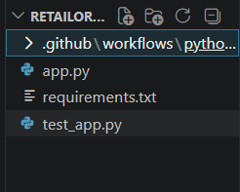

API IMPLEMENTATION

The application provides REST API endpoints for monitoring service health, checking order processing status, and validating inventory availability.

The APIs were successfully executed through the local Flask development server.

AUTOMATED TESTING
Automated testing was implemented using Pytest. Test cases were created for all API endpoints to validate successful response status codes.

All tests executed successfully, confirming that the APIs were functioning correctly.

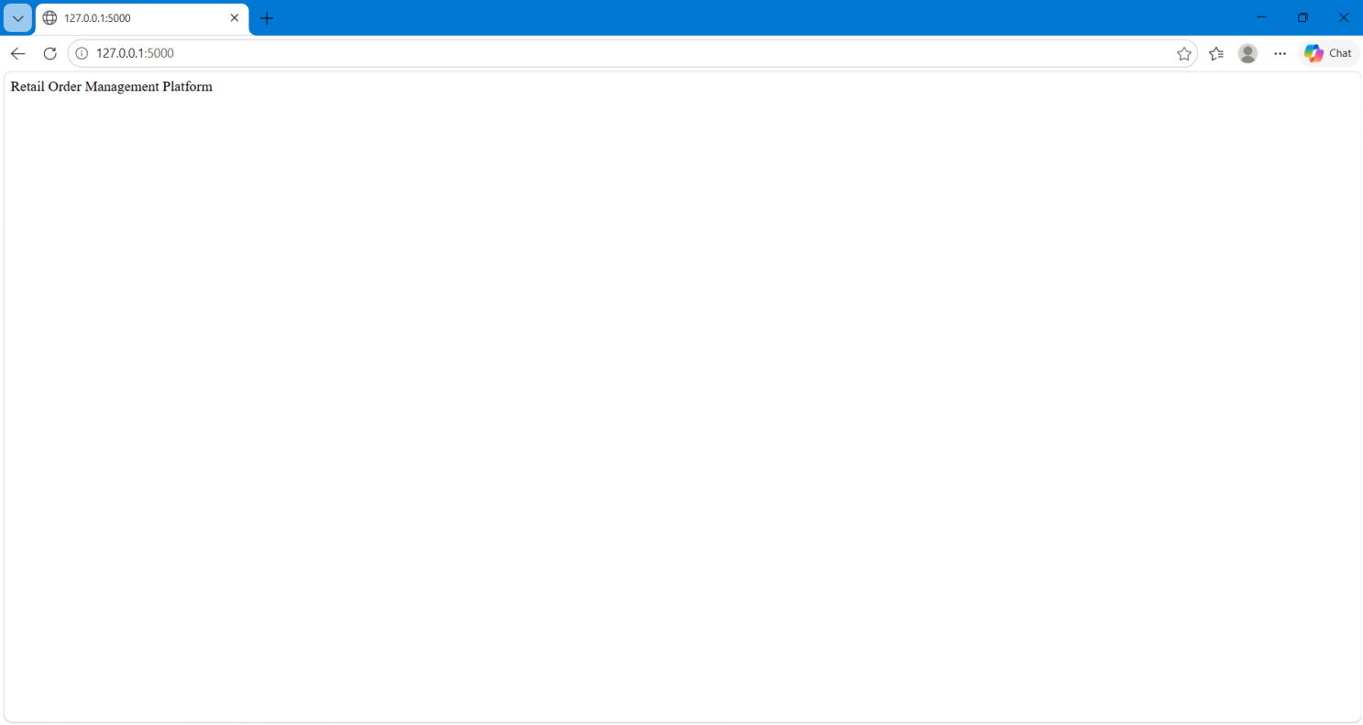

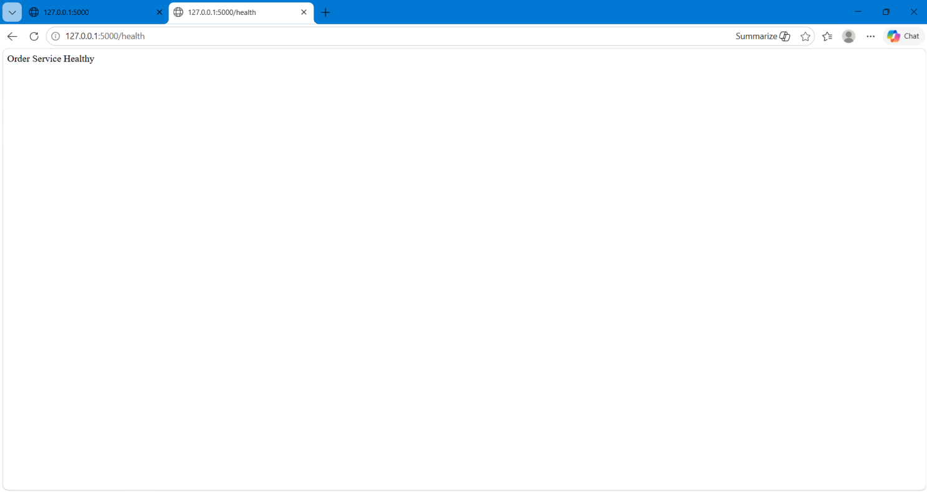

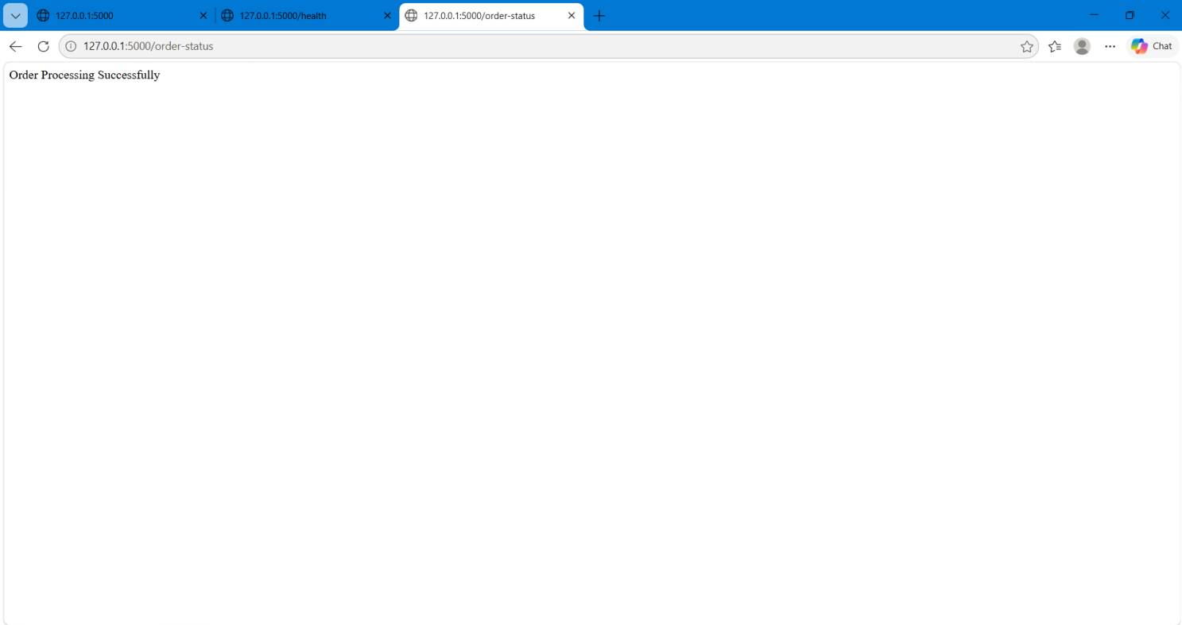

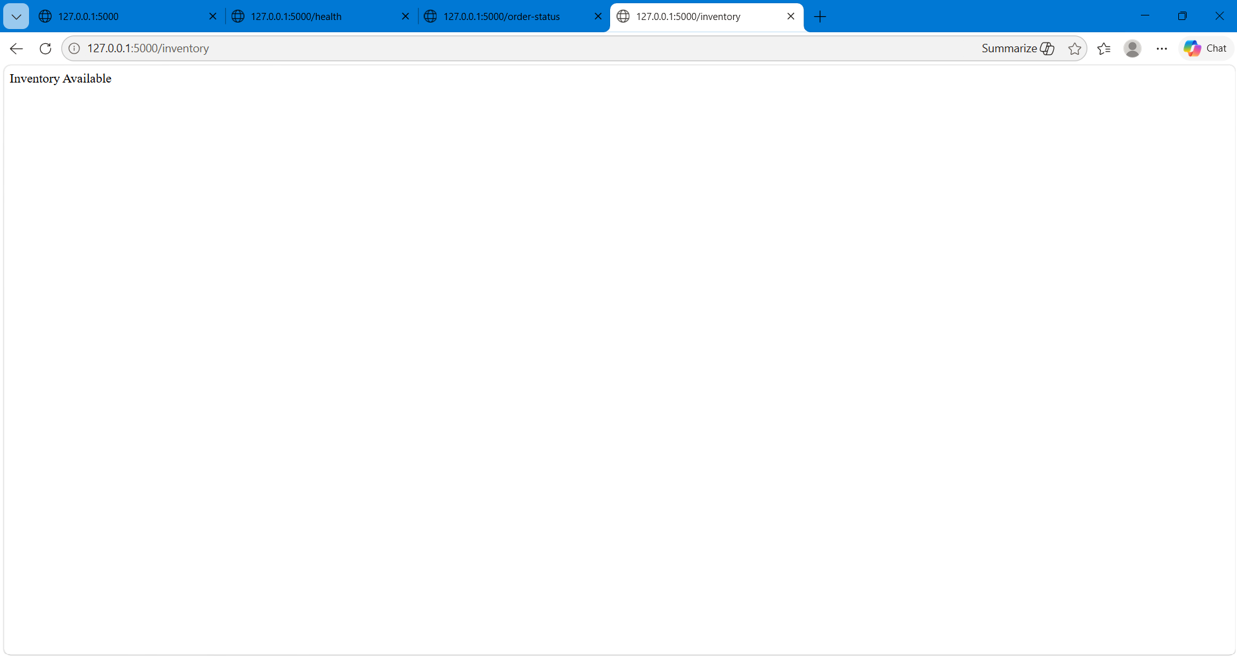

GITHUB REPOSITORY MANAGEMENT

GitHub was used as the source control platform for managing the application code. The project repository contains the Flask application, test scripts, requirements file, and GitHub Actions workflow configuration.

The code was pushed successfully using Git commands from Visual Studio Code terminal.

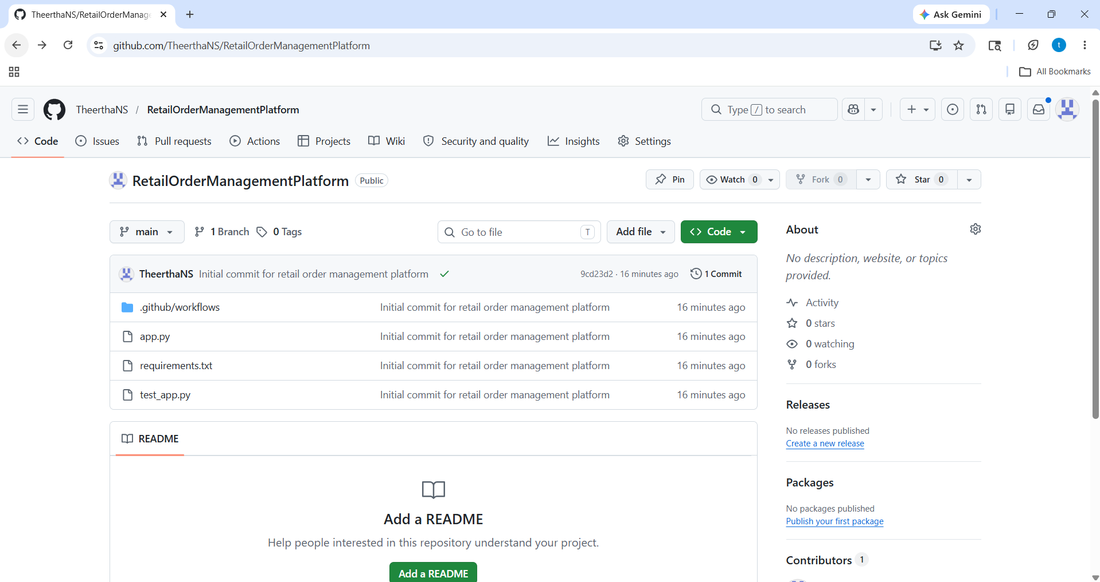

GITHUB ACTIONS CI PIPELINE

GitHub Actions was used to automate the Continuous Integration workflow. The CI pipeline automatically installs dependencies and executes automated tests whenever code is pushed to the main branch.

The workflow execution completed successfully, validating the build and test process.

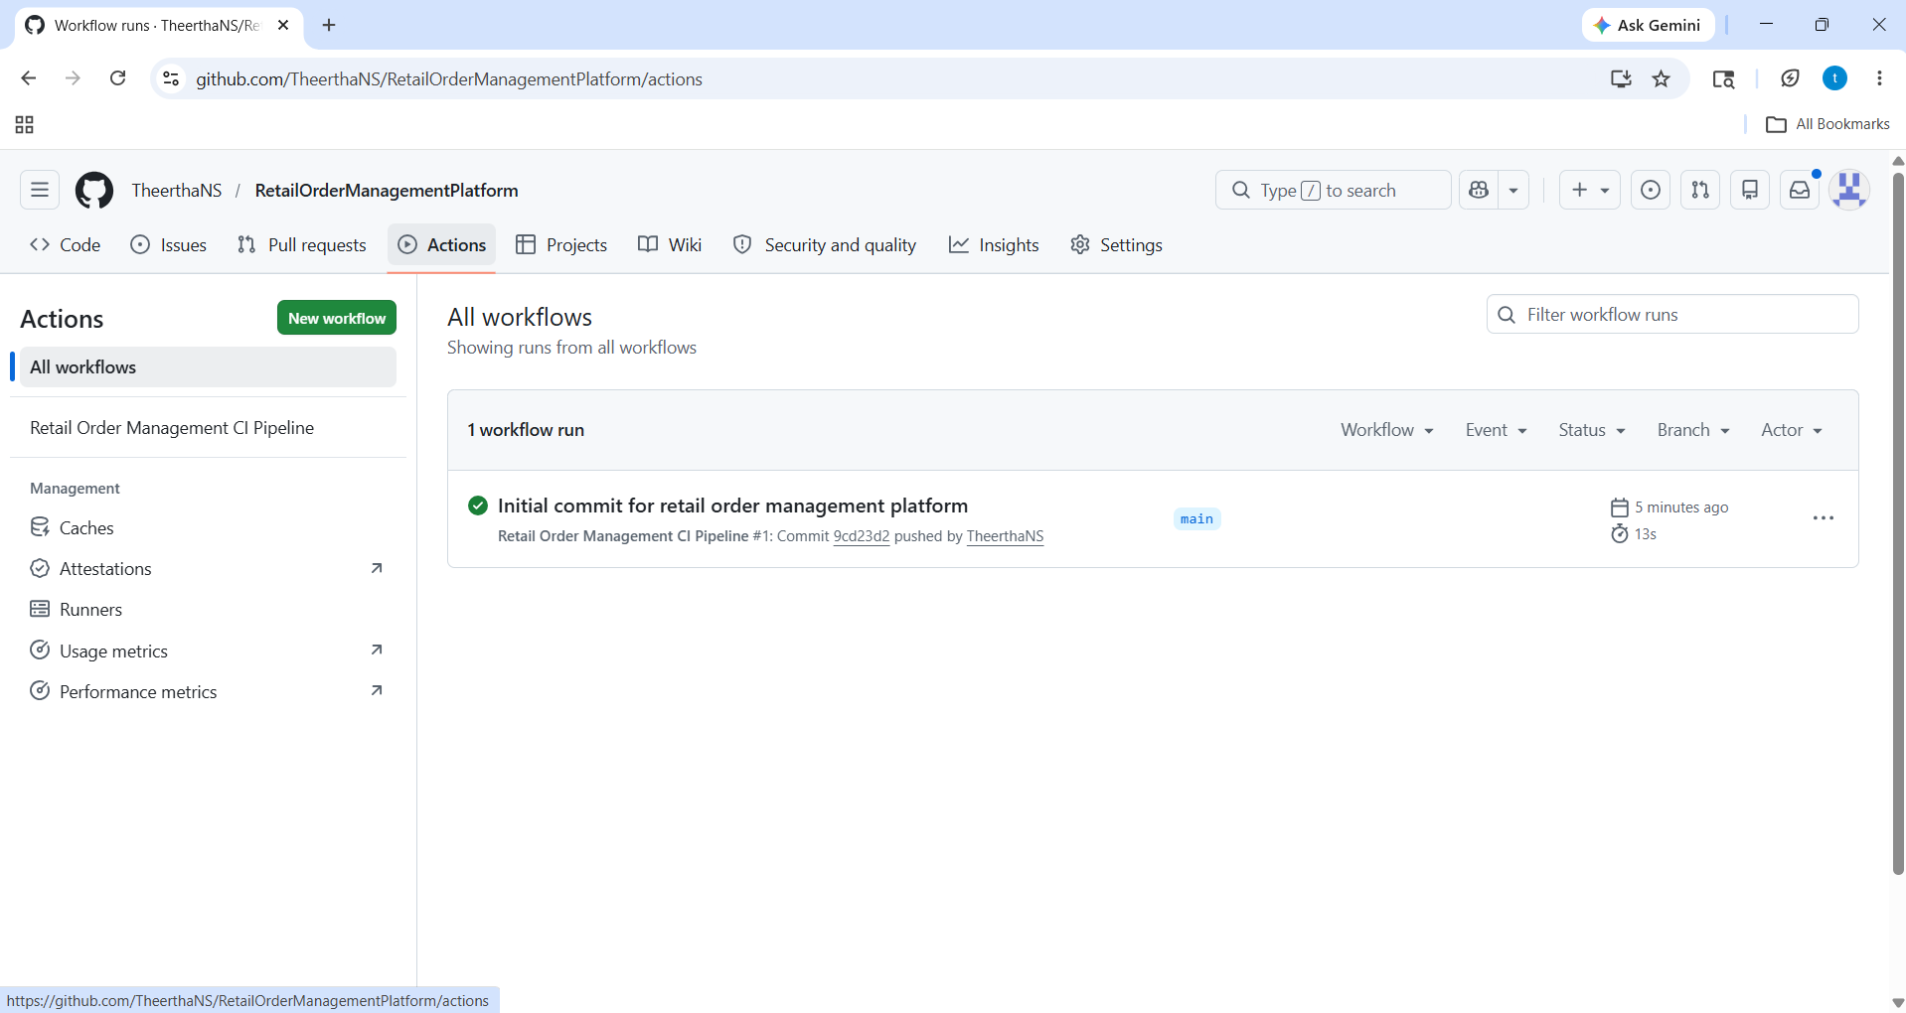

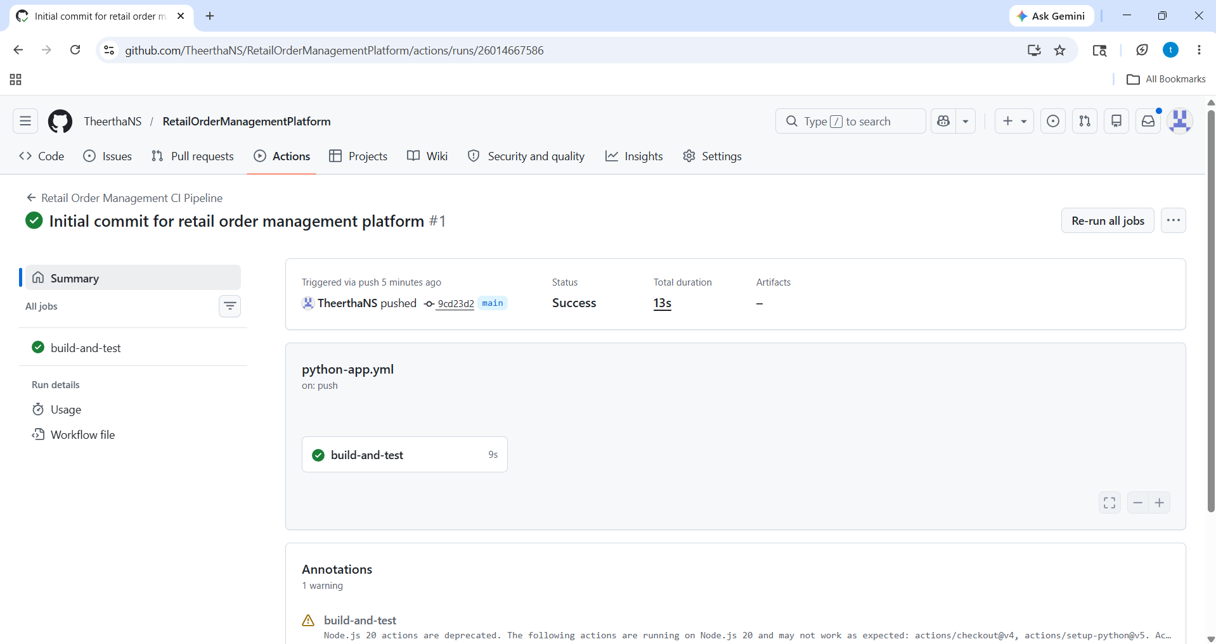

TRELLO AGILE PLANNING

Trello was used for Agile project planning and task management. The project board was divided into multiple lists such as Backlog, Features, User Stories, Tasks, In Progress, and Completed.

Features, user stories, and tasks were created to simulate a real-world DevOps workflow followed by a retail engineering team.

FEATURE AND USER STORY BREAKDOWN

The project was divided into features and user stories for better project tracking and execution.

Major Features:
• Flask API Development
• GitHub Repository Setup
• Automated Testing
• CI Pipeline Configuration
• Build Verification

User Stories:
• As a user, I want to check order status.
• As an admin, I want inventory visibility.
• As a developer, I want automated testing.
• As a DevOps engineer, I want CI automation.

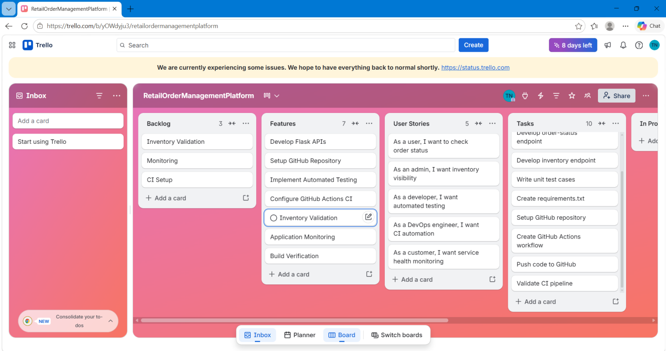

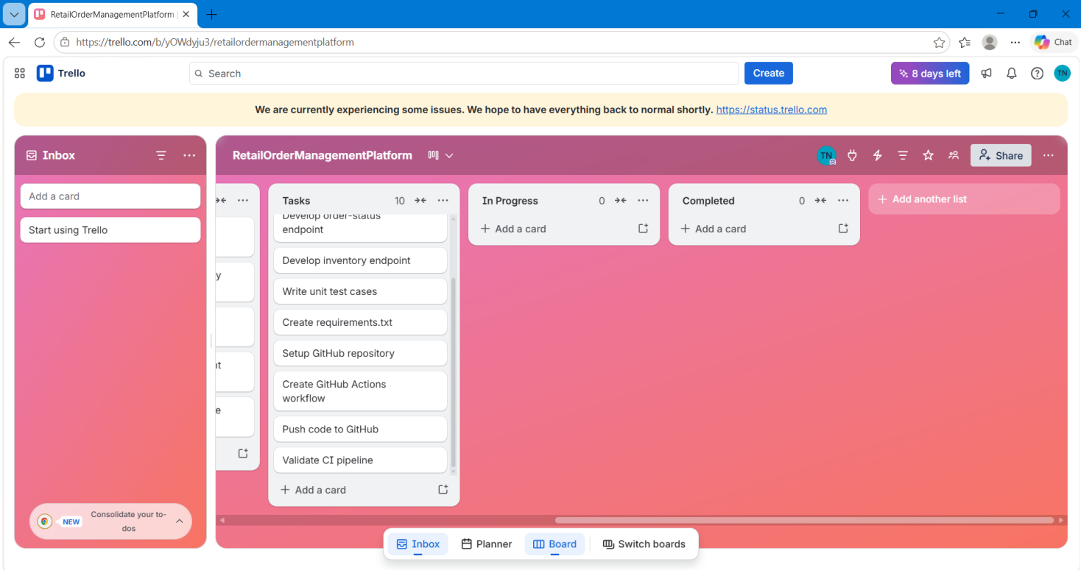

PROJECT VERIFICATION

The project was verified successfully with the following validations:

• Source code pushed successfully to GitHub
• GitHub Actions workflow triggered automatically
• CI pipeline executed successfully
• All automated tests passed
• Flask APIs executed successfully

CONCLUSION
This project successfully demonstrated the implementation of a DevOps workflow for a Retail Order Management Platform using Agile planning, source control management, automated testing, and Continuous Integration practices.

The project provided practical experience in Flask API development, GitHub repository management, GitHub Actions automation, and Agile task planning using Trello.

